
BIRKERØD GYMNASIUM,
HF, IB & KOSTSKOLE

IB DIPLOMA PROGRAMME
Test 1 P2

Mathematics Standard Level SL
Test on Straight Lines, Surds, Sets and Venn Diagrams, Data and Sampling and Statistics

October 2019
GDC
35 minutes

Instructions to candidates:
- Write down your name in the space provided.
- You can open this paper when given to you, but you will not be able to use your calculator until instructed.
- A graphic display calculator must be used for this test.
- Answer all the questions.
- Write your answers in the spaces provided.
- You are advised to show all working, where possible. Where an answer is wrong, some marks may be given for correct method, provided this is shown by written working.
- Unless otherwise stated in the question, all numerical answers must be given exactly or rounded to 3 significant figures.

Points:_______________/ 41 Grade:

Name:______________________________________________________________________________________

Teacher: (AA, ARC or ANU) ______________________________________________________________
1. The lengths of trout in a fisherman’s catch were recorded over one month, and are represented in the following histogram.
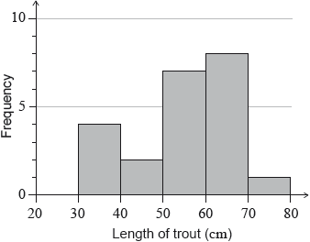

(a) Complete the following table. [2 marks]

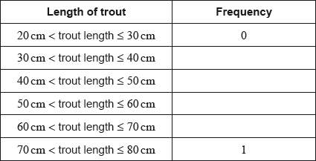

(b) State whether length of trout is a continuous or discrete variable. [1 mark]

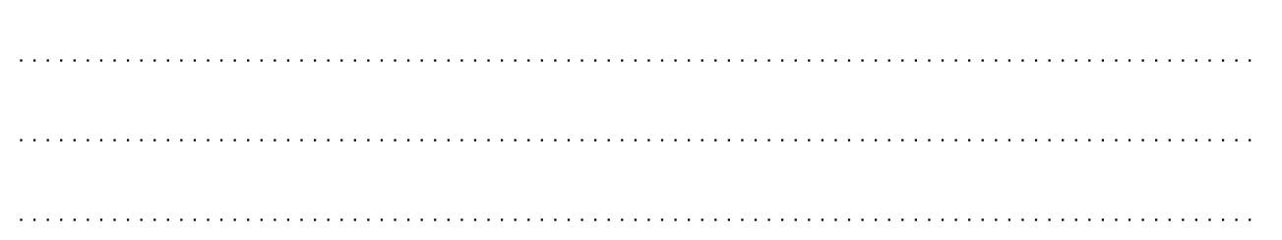

(c) Write down the modal class. [1 mark]

Any trout with length 40 cm or less is returned to the lake.

(d) Calculate the percentage of the fisherman’s catch that is returned to the lake. [2 marks]

(e) Estimate the mean trout length. [2 marks]

(f) Estimate the standard deviation of the trout lengths. [1 mark]

2 . Consider the following Venn diagrams.
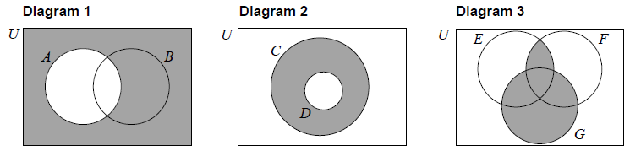

(a) Write down an expression, in set notation, for the shaded region represented
by Diagram 1. [1 mark]

(b) Write down an expression, in set notation, for the shaded region represented by Diagram 2.
[1 mark]

(c) Write down an expression, in set notation, for the shaded region represented by Diagram 3.
[2 marks]

(d) Shade, on the Venn diagram, the region represented by the set 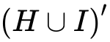. [1 mark]



(e) Shade, on the Venn diagram, the region represented by the set 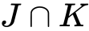. [1 mark]



3.
Consider the numbers 3, −5 , 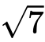, 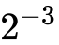 and 1.75.
Complete the table below, placing a tick () to show which of the number sets, 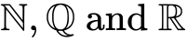 these numbers belong to. The first row has been completed as an example.

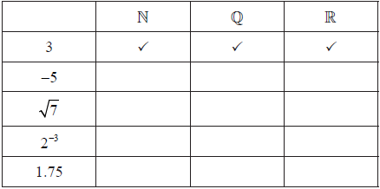

[6 marks]

4. The coordinates of point A are 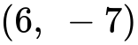 and the coordinates of point B are 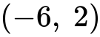. Point M is the midpoint of AB.
(a) Find the coordinates of M. [2 marks]



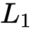 is the line through A and B.

(b) Find the gradient of . [2 marks]

The line 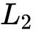 is perpendicular to and passes through M.
(c) Write down the gradient of . [1 mark]

(d) Write down, in the form 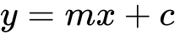, the equation of . [1 mark]

5. A city hired 160 employees to work at a festival. The following cumulative frequency curve shows the number of hours employees worked during the festival.
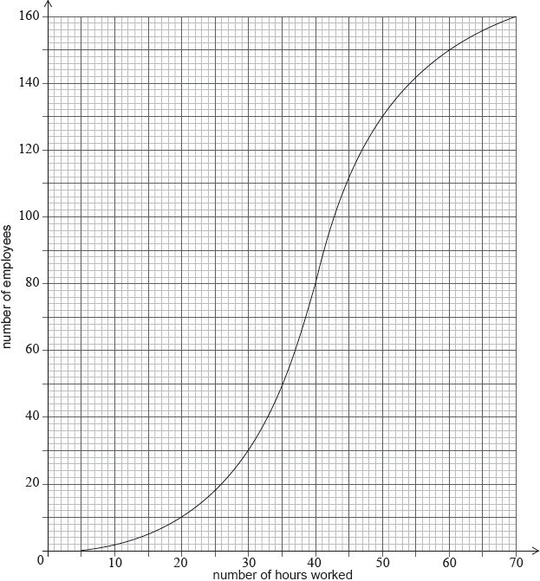
(a) Find the median number of hours worked by the employees. [1 marks]

(b) Write down the number of employees who worked 50 hours or less. [1 mark]

(c) Only 10% employees worked more than hours. Find the value of . [2 marks]

6. An annual dog show averages 3540 visitors. The catering manager is conducting a survey to investigate the proportion of visitors who will spend more than $20 on food and drinks at the show.

(a) If he decides to survey the first 40 people through the gate, identify the sampling method used.
[2 marks]

(b) If he decides to survey every 20th person through the gate, identify the sampling method used.
[2 marks]

7. Find the shaded area: [6 marks]
